OPERATING SYSTEMS – ASSIGNMENT 1
24k-0654
Armeen Azam
BCS – 4F

CONFIGURING NEW KERNEL

- Downloading Dependencies

Commands:

$ sudo add-apt-repository "deb http://archive.ubuntu.com/ubuntu $(lsb_release -sc) main universe"
$ sudo apt-get update
$ sudo apt-get install libncurses5-dev
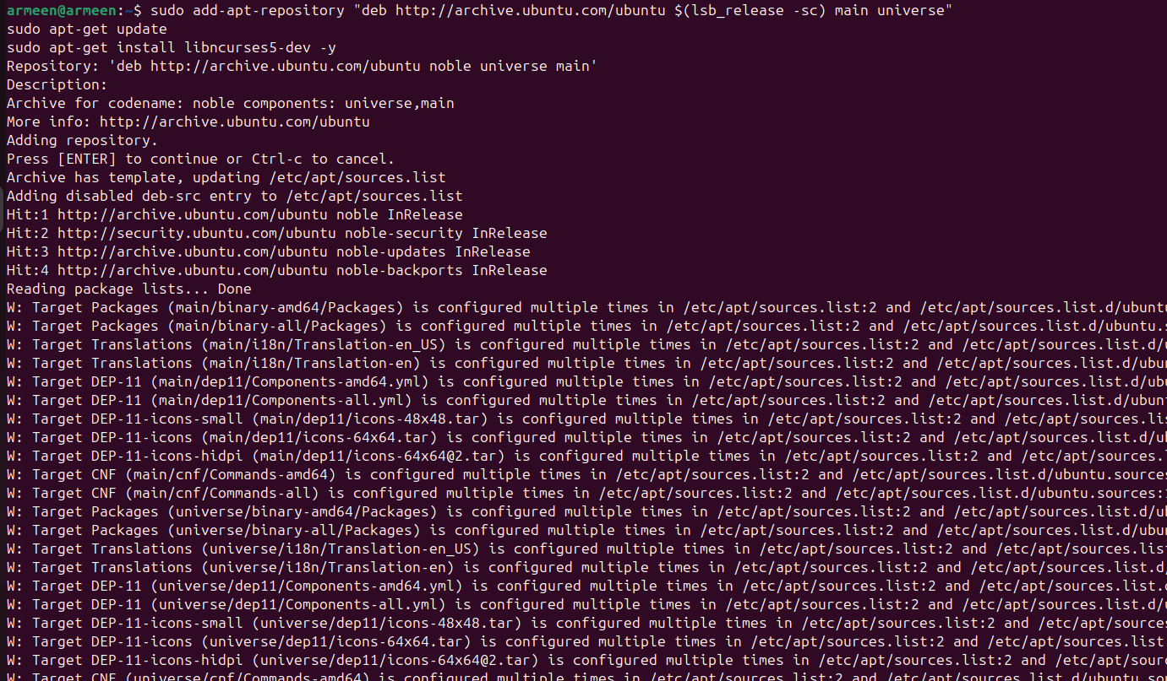

CDK is a library written in C that provides a collection of widgets for text user interfaces (TUI)
development. The widgets wrap n-curses functionality to make writing full screen curses
programs faster.

- OpenSSH/OpenSSL:

Commands:

$ sudo apt-get install libssl-dev
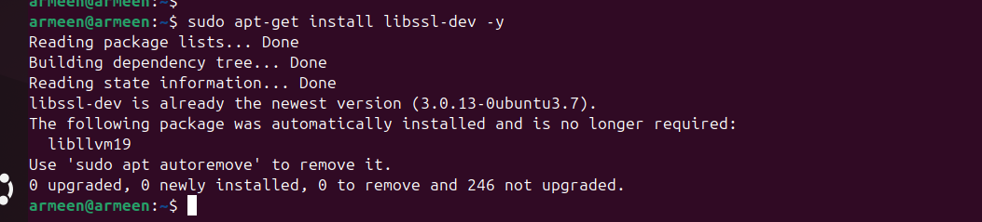

OpenSSL is a robust, commercial-grade, and full-featured toolkit for the Transport Layer
Security (TLS) and Secure Sockets Layer (SSL) protocols. It is also a general-purpose
cryptography library.

Downloading Kernel:

Commands:

$ sudo -i
$ mkdir /kernels
$ cd /kernels
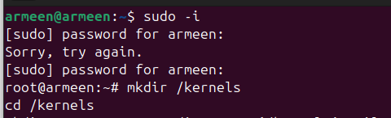
Go inside the root directory and create kernels then go inside kernels.

/kernels$ wget https://cdn.kernel.org/pub/linux/kernel/v6.x/linux-6.8.tar.xz
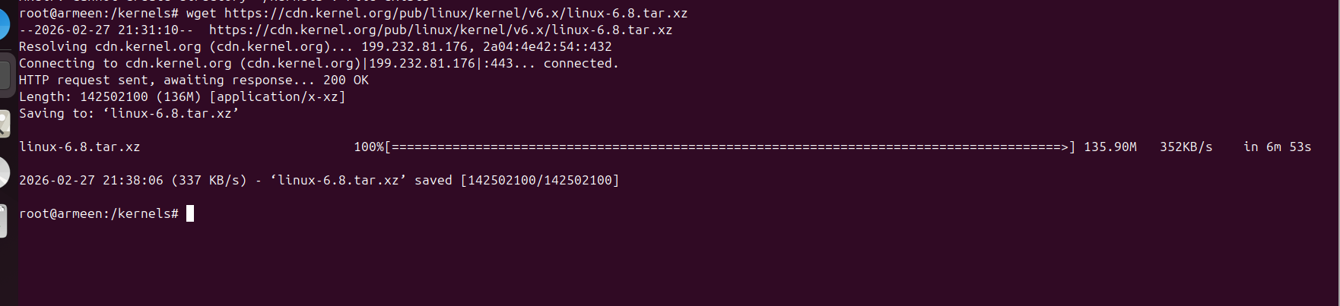

/kernels$ tar xf linux-6.8.tar.xz
/kernels$ cd linux-6.8
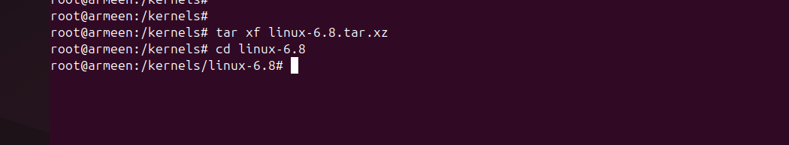
Downloaded Linux kernel 6.8 source code from kernel.org and extracted it into /kernels directory.

4. Configuring Kernel in Linux System

Snapshot of the current state before further configuration.
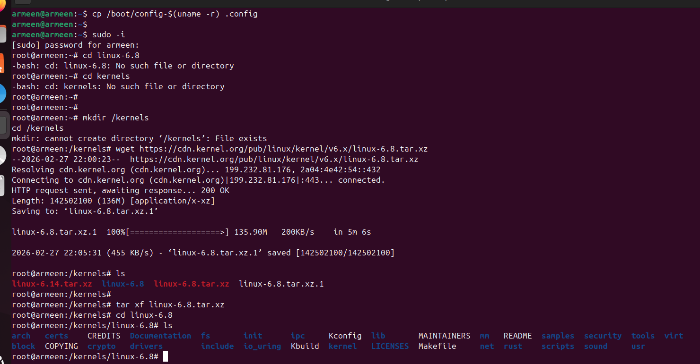

5. Copy Old Config File to Our New Kernel Folder

Commands:

$ ls /boot | grep config
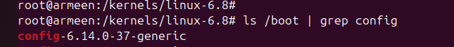

$ cp /boot/config-$(uname -r) .config
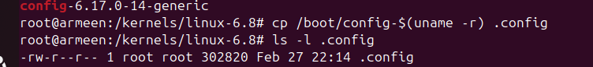

Copied the current running kernel configuration file to use as base configuration for the new kernel.

6. Naming the Kernel:

Command:

/kernels/linux-6.8 $ gedit Makefile
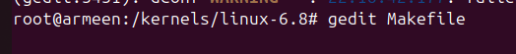

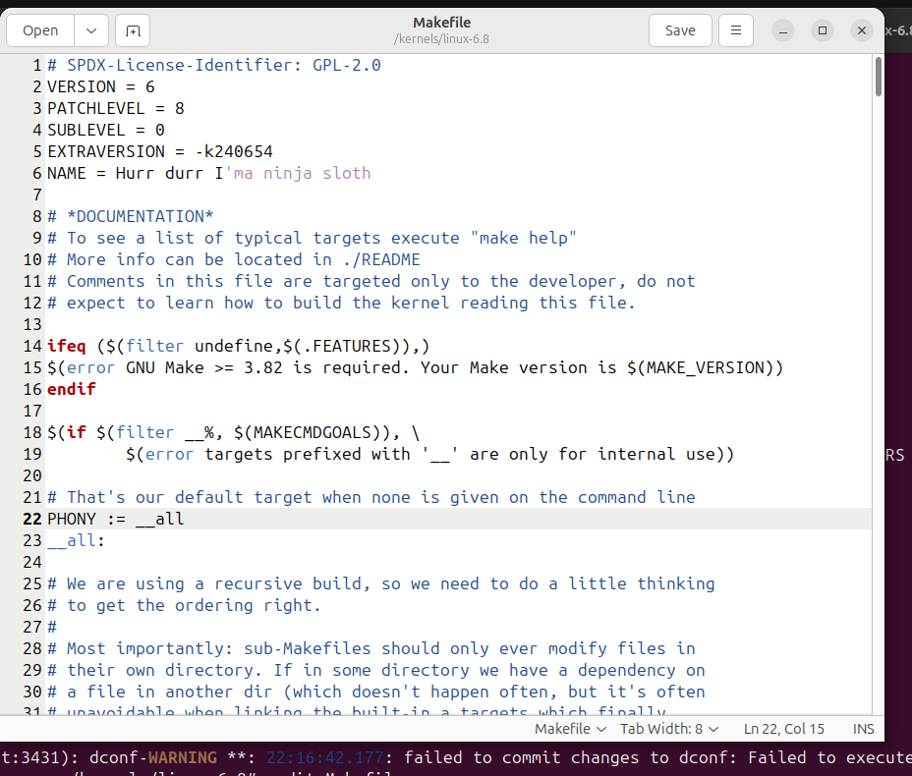
Modified the Makefile to change EXTRAVERSION so that the new kernel displays my roll number (24k-0654) when uname -r is executed.

7. Setting Configuration Parameter

Command:

/kernels/linux-6.8 $ yes ‘’ | make oldconfig -j4

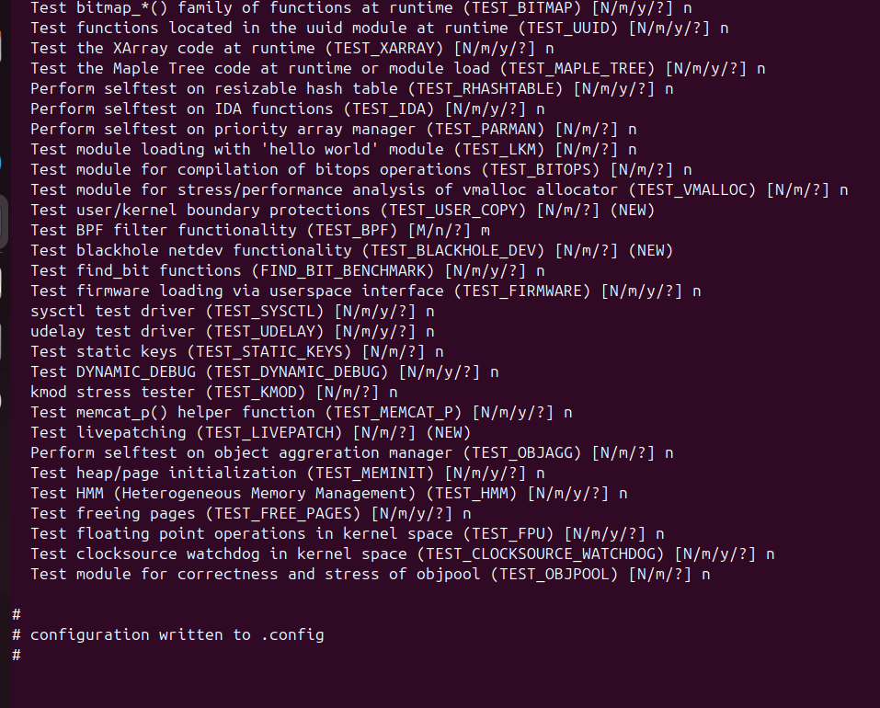
Set configuration for .config file

/kernels/linux-6.8 $ make clean -j4
Cleaned previous build files to ensure fresh compilation.

8. Building Kernel:

Command:
/kernel/linux-6.8 $ make bzImage -j4
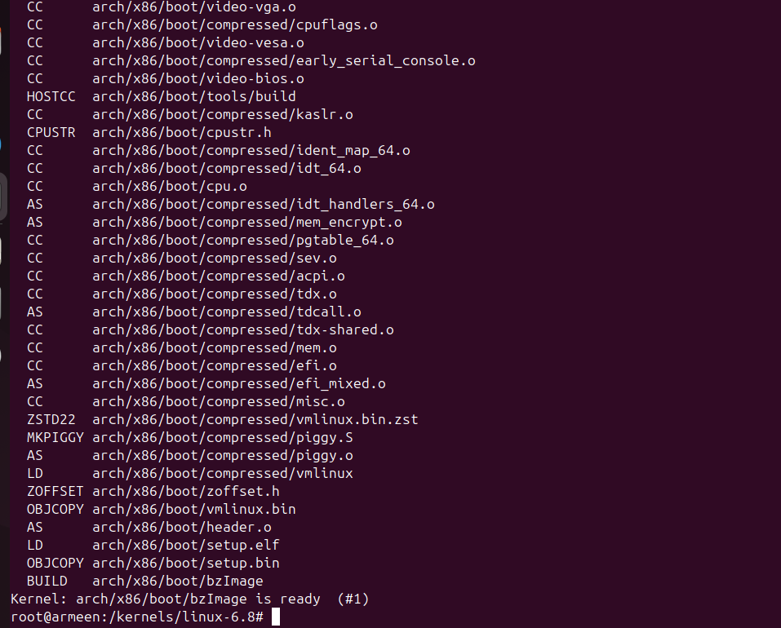

Compiled the kernel image using 4 CPU cores for faster processing.

9. Make the New Kernel Bootable

Step 1) Install Compress Kernel Image into the Boot Directory:

Commands:

make modules -j4
make modules_install -j4
make install -j4
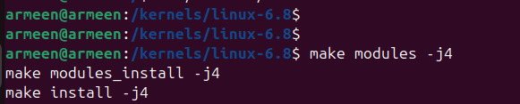

Step 2) Install Compress Kernel Image into the /boot Directory

Command:

sudo update-initramfs -c -k <kernel-version>
In modern day Ubuntu, we don’t need to run this command as this work is done by module installation commands.

Step 3) Update GRUB

Command:

sudo update-grub
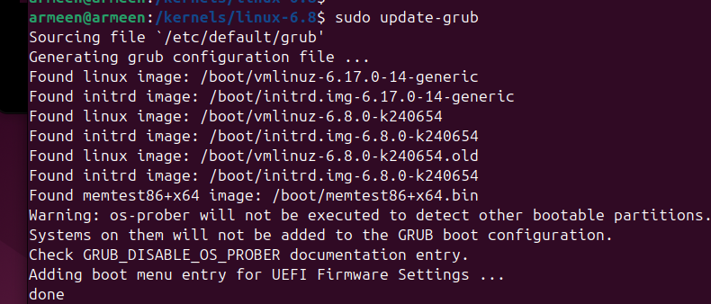
This updates the GRUB menu to boot into your custom kernel.

MAKING A SYSTEM CALL

STEP 1: Go to Kernel Source Folder
Command:
cd /kernels/linux-6.8
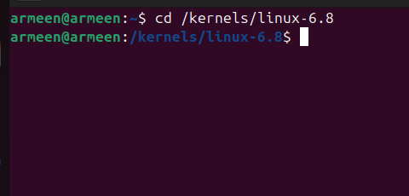

STEP 2: Create the System Call File
Command:
cd kernel
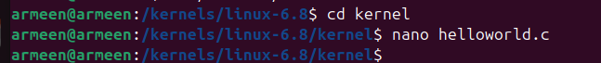

nano helloworld.c

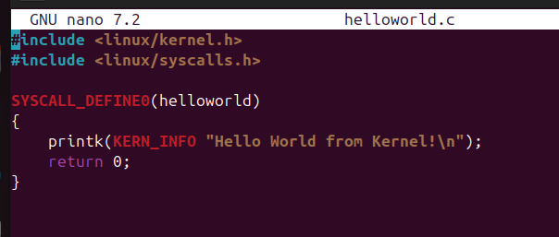
At the end this line will be printed.

STEP 3: Add File to Makefile
Command:

nano Makefile
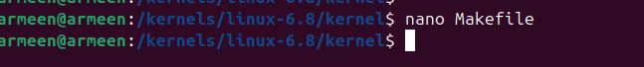

Find line starting with obj-y +=
Add helloworld.o at the end
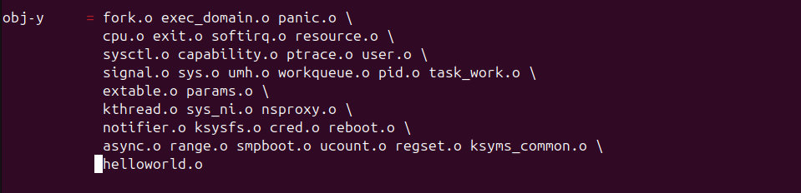

This tells the kernel to compile your file.

STEP 4: Register the System Call
Command:
cd ..

Open syscall table:
nano arch/x86/entry/syscalls/syscall_64.tbl

Add this line:
548 common helloworld sys_helloworld
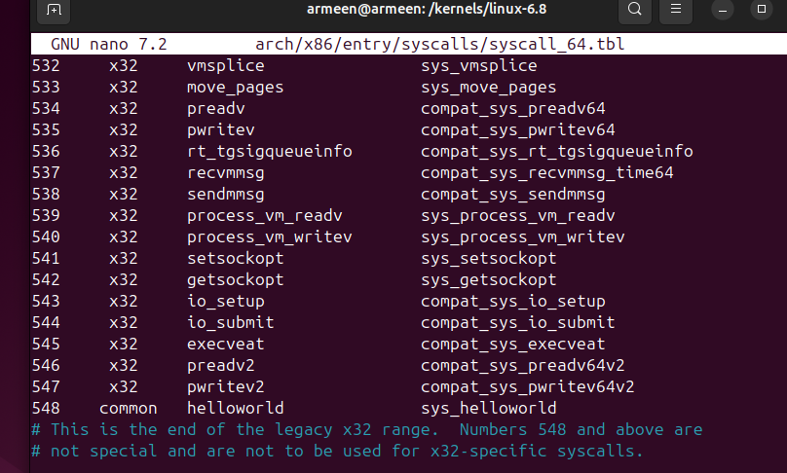

This connects syscall number 548 to your function.

STEP 5: Build the Kernel
Commands:
make -j4 bzImage
make modules -j4

STEP 6: Install the Kernel
Commands:
sudo make modules_install
sudo make install
sudo update-grub

Found Linux 6.8.0-k240654 – this one is the custom kernel, we configured.

STEP 7: Reboot into Custom Kernel
Command:
sudo reboot
When system starts:
- Hold Shift
- Select Advanced options
- Choose:
6.8.0-k240654

STEP 8: Confirm You Are in Custom Kernel
Command:
uname -r
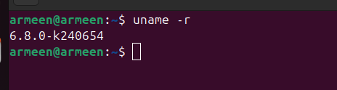

STEP 9: Create User Program
Command:
nano test.c
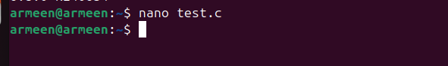
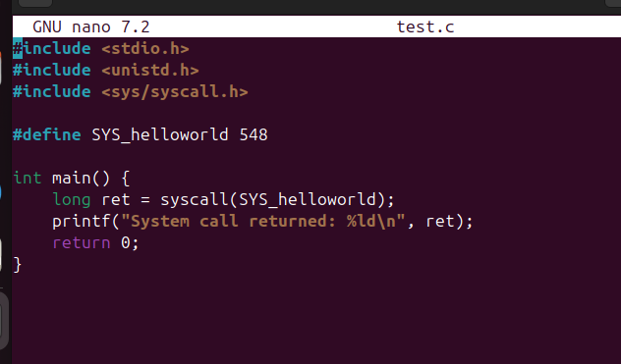

STEP 10: Compile and Run the Test Program
Command:

gcc test.c -o test
./test
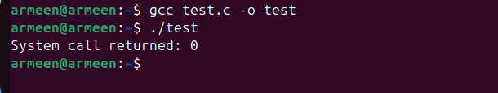

STEP 11: Check Kernel Output
Command:
sudo dmesg | tail
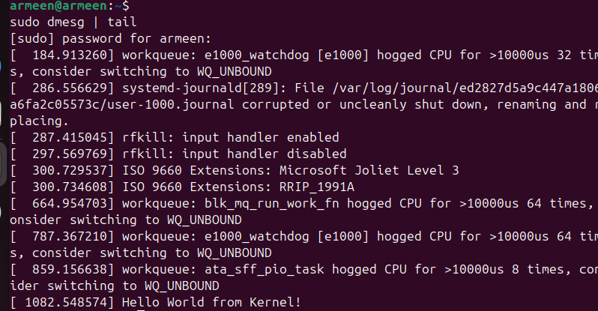

The line “Hello World from kernel “ is printed by HelloWorld system call.

